APPLICATION FOR A CL:AIRE RESEARCH PROJECT
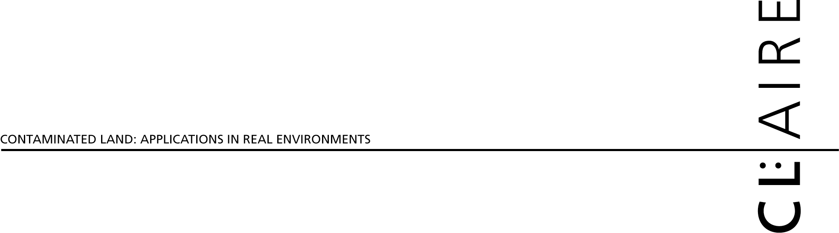

CL:AIRE
32 Bloomsbury Street
London
WC1B 3QJ

Tel: 020 7299 4250
Fax: 020 7299 4259

Project No for CL:AIRE use only

1.0 DETAILS

Principal Investigator:
Current Post & Period held:
Name & Address of Institute and Department:
Telephone: | Fax: |  |  | E-mail:
Co-applicant(s) and position held:
Name and address of Institution and Department:
Project Title (20 Words or less):
Project Abstract (100 words or less include summary of objectives):

Describe the elements of this project that are innovative:

Describe the regulatory licensing requirements for this project:

Describe the principal benefits of this project:
Cost of the Research per annum and total value:
Project Duration in Months |  | Proposed Start Date

Status of Funding:

2.0 PROJECT INFORMATION

Summary of funds requested: | Year 1  £ | Year 2  £ | Year 3  £

Staff
Travel & Subsistence
Consumables
Exceptional items
Equipment
Indirect

CL:AIRE Facility cost
Total Costs

Please tick box to show that 1 page CV is attached for Principal Investigator and co applicants

Description of the Research Project
Please ensure that you address these points:
- How does the project fit within CL:AIRE’s Priorities for Technology Demonstration and Research?
- Underlying rationale and scientific and technological issues being addressed including: degree of innovation, by reference to state of the art in UK, Europe and Worldwide; and feasibility, by reference to previous work carried out by yourself and others.
- Project aims and objectives.
- Describe your project in terms of: the size of the problem and how your research will help towards tackling this, and the benefits that the project will provide to others (ie cost/benefit, or ideally risked cost benefit if possible).
- Methodology and approach (identify protocols, sampling locations and frequency of sampling, analytical methods etc where applicable. Identify other processes that may result in contaminant loss and describe how your work plan will quantify these losses.)
- Practicability
- Sustainability
- Project management procedures
- Anticipated outcomes
- Project reporting and dissemination of the results
- Project schedule (identify milestone, review points and dates)

Description of the Research Project (Cont’d)
- How does the project fit within CL:AIRE’s Priorities for Technology Demonstration and Research?

- Underlying rationale and scientific and technological issues being addressed including: degree of innovation, by reference to state of the art in UK, Europe and Worldwide; and feasibility, by reference to previous work carried out by yourself and others.

- Project aims and objectives.
- Describe your project in terms of: the size of the problem and how your research will help towards tackling these and the benefits that the project will provide to others (ie cost/benefit, or ideally risked cost benefit if possible).

Description of the Research Project (Cont’d)
- Methodology and approach (identify protocols, sampling locations and frequency of sampling, analytical methods etc where applicable. Identify other processes that may result in contaminant loss and describe how your work plan will quantify these losses)
- Practicability: Please give details on how your project will work with or address the following:
Specific site conditions (including ground conditions and nature and extent of contaminants)
Variable form of the contaminants (concentration, physical/chemical form, association)
Potential interferences from other contaminants
The site context (e.g. site access, available space, services, current land-use, site location)
Project time-scales, seasonality
Verification of progress and outcome (e.g. sample design, sampling and analytical protocols, measurable changes, clear objectives)
Likely health, safety, and environmental impacts, regulatory issues
- Sustainability: Please describe any parts of your project where you are endeavouring to measure sustainability aspects (e.g. vehicle movements; carbon emissions; reuse of materials)

- Project management procedures: Please give details on the following:
Identify the management structure for the project (including reporting requirements)
Clearly allocate roles and responsibilities of project team
Detail experience and skills that the project team has to undertake this project and any practical experience that the project team has to deal with logistics and problems of a field trial
Detail the track record that the project team has in delivering similar types of projects

- Anticipated outcomes.
- Project reporting and dissemination of the results
- Project schedule (identify milestones, review points and output dates)

Discuss the risks involved with the project under a worst case scenario:

3.0 SITE REQUIREMENTS

CL:AIRE Site No: for CL:AIRE use only

Preferred geographical location of the site:
Preferred contaminant conditions: (refer to nature, general concentrations and distribution of contaminants and general level of site characterisation required.)
Preferred site conditions: (refer to requirements for access, site security, field/office buildings, electricity, water etc)
Preferred ground conditions: (including depth to groundwater):(refer to natural ground or made ground, drainage, geology and hydrogeology)

Timing Requirements: (refer to start date, completion date, number and timing of visits to the site)

Signature …………………….……………………………………………… Date……………………………………

Name (in block letters) ……………………………………………………………………………………………………

