CL:AIRE
32 Bloomsbury Street
London
WC1B 3QJ

Tel: 020 7299 4250
Fax: 020 7299 4259

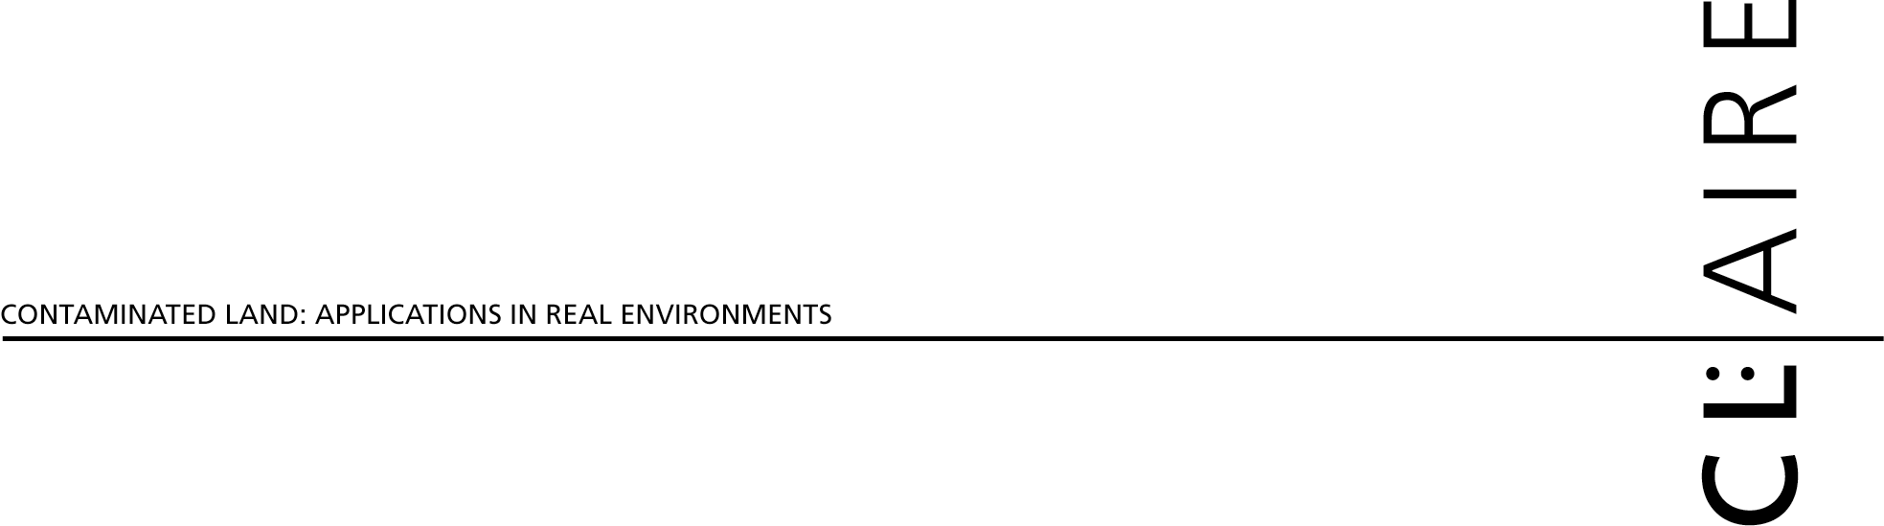

Project No for CL:AIRE use only

1.0 DETAILS

Contact Name:
Job title
Name & Address of Organisation:
Telephone: | Fax: | E-mail:
Other organisations involved:
Project Title (20 Words or less):
Project Abstract (100 words or less include summary of objectives):

Describe the elements of this project that are innovative:
Describe the regulatory licensing requirements for this project:
Describe the principal benefits of this project:
Project Duration in Months | Proposed Start Date

- PROJECT INFORMATION

Please tick box to show that 1 page CV is attached for Project Manager

and members of the demonstration team

Description of the Technology Demonstration Project
Please ensure that you address these points:
- How does the project fit within CL:AIRE’s Priorities for Technology Demonstration and Research?
- Introduction and project aims and objectives
- Description of technology and scientific basis (must be sufficiently detailed so that evaluators can understand the fundamental processes involved – include schematic flow diagram if applicable)
- Methodology and approach (identify protocols, sampling locations, frequency of sampling, and analytical methods. Identify processes other than the technology which may result in contaminant reduction or loss and discuss how the work plan will quantify these losses)
- Practicability
- Sustainability
- Project management procedures
- Identify sub contracted services (eg analytical laboratories)
- Identify proposed outcomes
- Project schedule (identify milestones and dates)
- Project reporting requirements

- How does the project fit within CL:AIRE’s Priorities for Technology Demonstration and Research?

- Introduction and project aims and objectives

Description of the Technology Demonstration Project (Cont’d)
- Description of technology and scientific basis (must be sufficiently detailed so that evaluators can understand the fundamental processes involved – include schematic flow diagram if applicable)

- Methodology and approach (identify protocols, sampling locations, frequency of sampling, and analytical methods. Identify processes other than the technology which may result in contaminant reduction or loss and discuss how the work plan will quantify these losses)

5.Practicability: Please give details on how your project will work with or address the following:
Specific site conditions (including ground conditions and nature and extent of contaminants)
Variable form of the contaminants (concentration, physical/chemical form, association)
Potential interferences from other contaminants
The site context (e.g. site access, available space, services, current land-use, site location)
Project time-scales, seasonality
Verification of progress and outcome (e.g. sample design, sampling and analytical protocols, measurable changes, clear objectives)
Likely health, safety, and environmental impacts, regulatory issues

6. Sustainability: Please describe any parts of your project where you are endeavouring to measure sustainability aspects (e.g. vehicle movements; carbon emissions; reuse of materials)

7. Project management procedures: Please give details on the following:
The management structure for the project (including reporting requirements)
Roles and responsibilities of project team
Experience and skills that the project team has to undertake this project and any practical experience that the project team has to deal with logistics and problems of a field trial
The track record that the project team has in delivering similar types of projects

8.Identify sub contracted services (eg analytical laboratories)
9.Identify proposed outcomes
10.Project schedule (identify milestones and dates)
11. Project reporting requirements

Has this technology been demonstrated elsewhere? Please provide details on number of times and where:
Discuss the risks involved with the project under a worst case scenario:

- SITE REQUIREMENTS (please complete if you would like CL:AIRE to help you find a site)

CL:AIRE Site No: for CL:AIRE use only

Preferred geographical location of site:
Preferred contaminated conditions:(refer to nature, general concentration and distribution of contaminants, and general level of site characterisation)
Preferred site conditions: (refer to requirements for access, site security, field/office buildings, electricity, water etc)
Preferred ground conditions (including depth to groundwater): (refer to natural or made ground, drainage, geology and hydrogeology)
Timing requirements: (start date, completing date, number and timing of visits to the site)

Signature………………………………………………………………………….. Date……………………………

Name (in block letters) ………………………………………………………………………………………………..

